1. 1. Yes, to execute a full branch, every statement will be tested.
      1. Sum (a, b), if( sum > 0), else if( sum < 0), else (do nothing). A sum of 0 will test all conditions.
   2. No, branches can have multiple statements, a single statement at 100% does not ensure another statement will be at 100% thus the branches won't be 100%
      1. if(something): do something. This statement is executed but there is no else or false statement.

| Inputs | Coverage % |
| --- | --- |
| x=3, y=4 | 7/9 = 78% |
| x=0.2, y=0.41 | 8/9 = 89% |
| Two scenarios added | 9/9 = 100% |



Statement Coverage: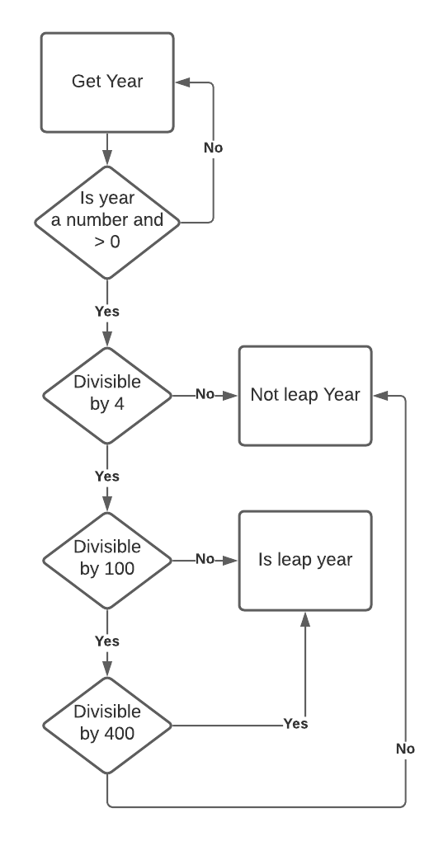

| Inputs | Coverage % |
| --- | --- |
| Year = “100” | 3/14 = 21% |
| Year = 100 | 7/14 = 50% |
| Year = 2020 | 7/14 = 50% |
| Year = 400 | 7/14 = 50% |

Branch Coverage:

| Inputs | Coverage % |
| --- | --- |
| Year = 10 | 1/6 = 16% |
| Year = 40 | 2/6 = 33% |
| Year = 100 | 3/6 = 50% |
| Year = 400 | 3/6 = 50% |

1. I do not count END IF as a statement thus there are 7 lines

| Inputs | Outputs | Statement Coverage |
| --- | --- | --- |
| Hour = 13, temp = 77 | Eat lunch  Go  Swim | 7/7 = 100% |
| Hour = 14, temp = 74 | Eat lunch  Go | 6/7 = 86% |

1. The read temp and hour and first if is checked
2. The hour is checked if it's > 12, if it is (both inputs are), skip checking the temp conditional and print “eat lunch”.
3. Print “go”
4. Check conditional of temp, 77 is true, 74 is false
5. print “swim” accordingly